## **Part A – Table Creation**

1. Create a table **Department** with the following fields:  
   * dept_id (Primary Key)
   * dept_name

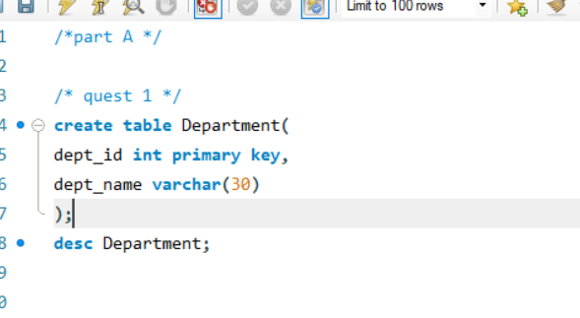

1. Create a table **Employee** with the following fields:  
   * emp_id (Primary Key)
   * emp_name
   * salary
   * dept_id (Foreign Key referencing Department)

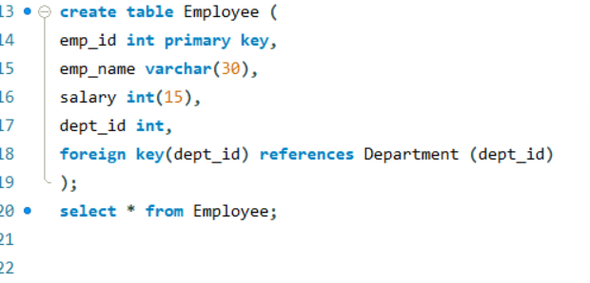

## **Part B – Data Insertion**

1. Insert at least 3 departments and 5 employees into the respective tables.  
   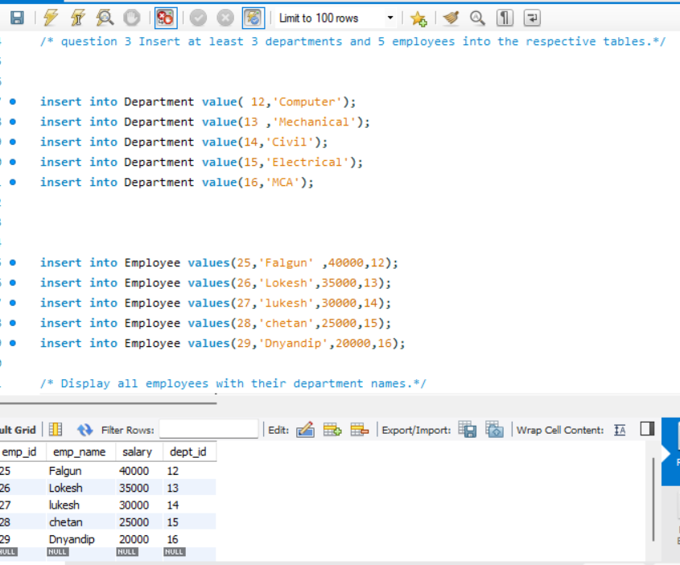

## **Part C – Queries to Solve**

1. Display all employees with their department names.
2. Find employees who work in the IT department.

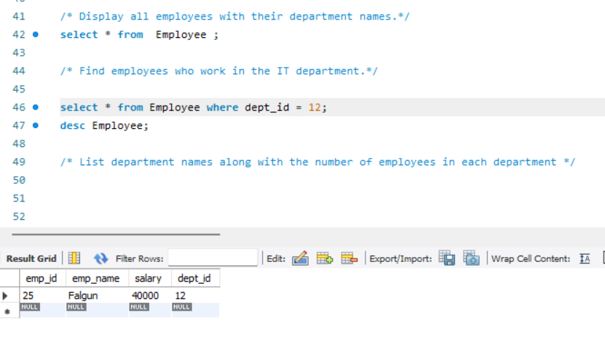

1. List department names along with the number of employees in each department.
2. Add a new employee 'Meena' in the department 'Finance'.

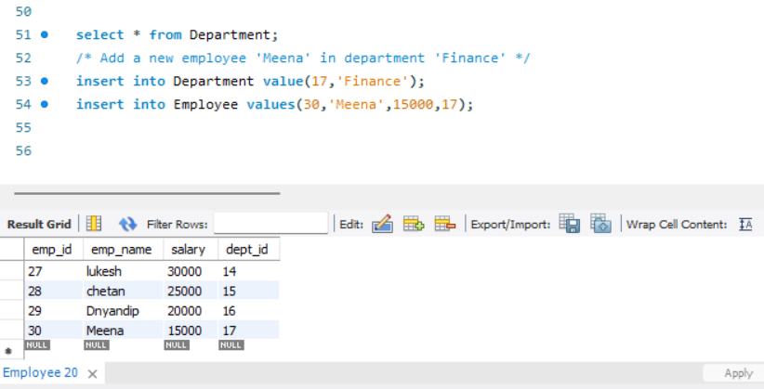

1. Try inserting an employee with a non-existing department id (say dept_id = 10). What happens? Why?

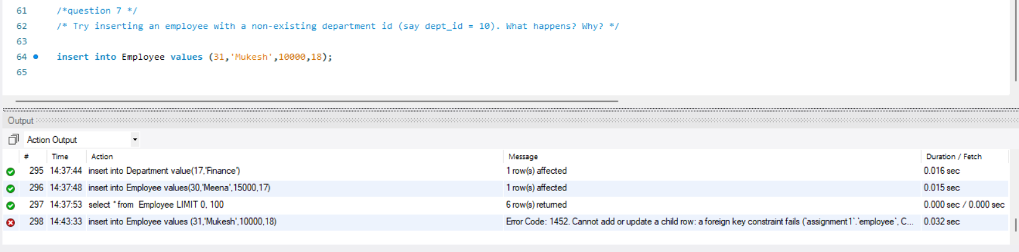

1. Delete the Finance department. What happens to employees in that department?  
   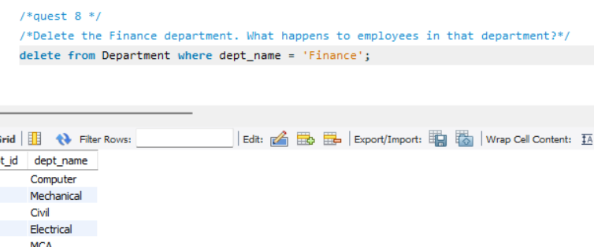

## **Part D – Advanced Tasks**

1. Modify the **Employee** table so that if a department is deleted, all its employees are also deleted (ON DELETE CASCADE).  
   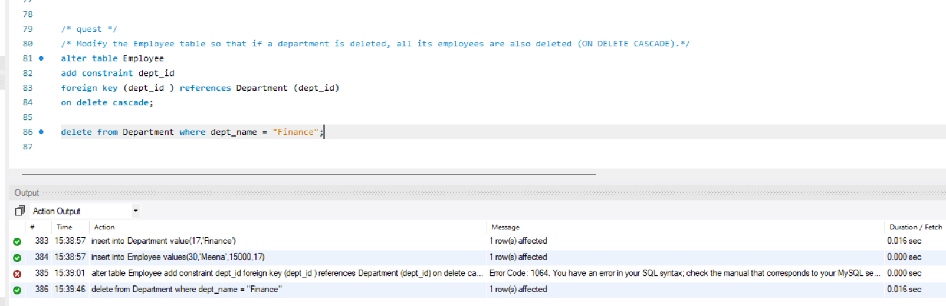
2. Verify the above by deleting the Finance department again.

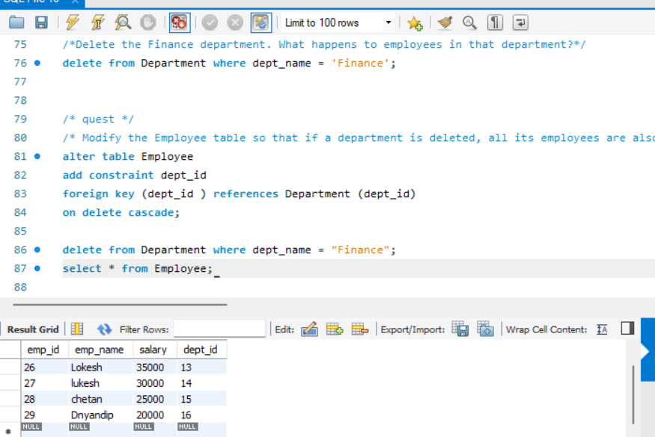

1. Modify the **Employee** table so that if the department_id in **Department** is updated, it should also update automatically in the **Employee** table (ON UPDATE CASCADE).

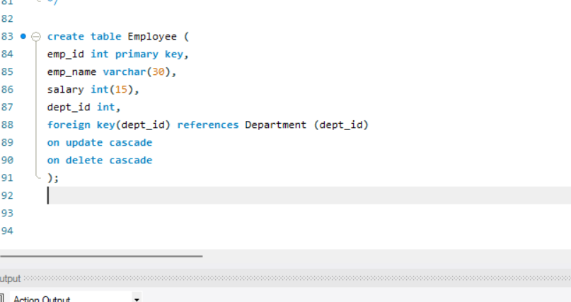

1. Verify by updating the dept_id of the IT department to a new value. What happens to the employees in that department?

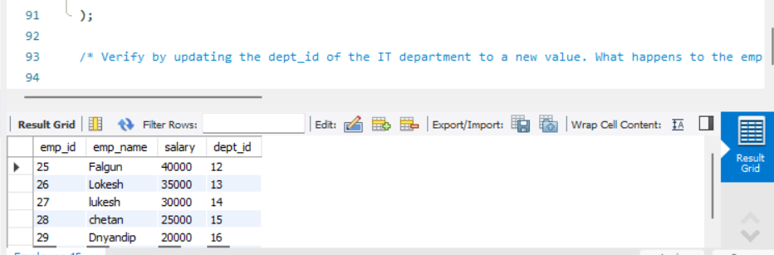

1. Change the Foreign Key constraint so that if a department is deleted, employees should have their dept_id set to NULL (ON DELETE SET NULL).  
   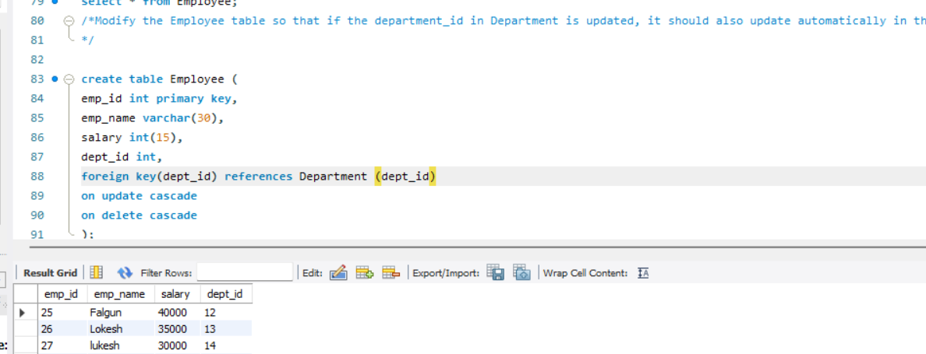
2. Test the above by deleting the HR department. What happens to the employees under HR?